DISTASH LIST
All items are in excellent condition except as noted. Buyer to pay all shipping costs. PayPal or Venmo accepted. For more information, contact me at thenaturalphoenix@outlook.com. Thank you for your consideration.

DISPLAY UNITS
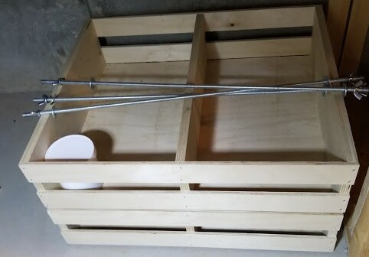
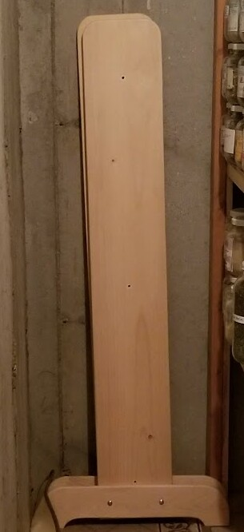

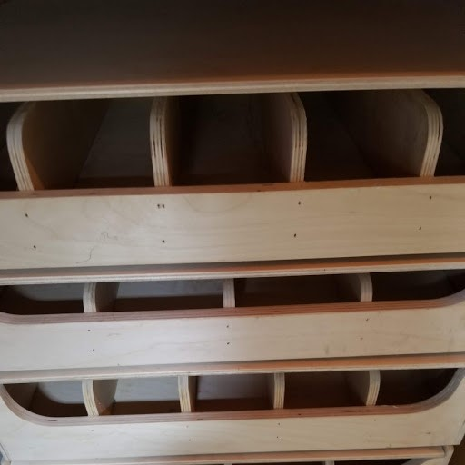

This beautiful unit is 60” Tall. It holds 7 drawers. Each of those drawers are 17” wide x 14” deep x 3.5” tall. 2 of the drawers have double dividers, and the others have more (pictured above). The multiple divided wooden drawers have lids with them as well. This is a quality unit in excellent condition. $250.00 Firm on this.

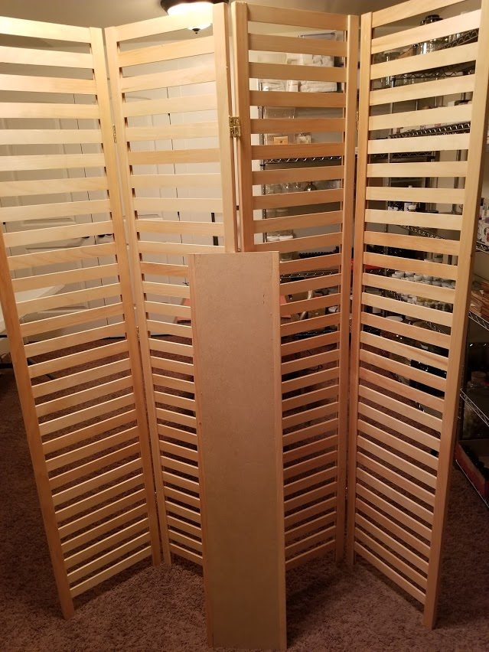
This is an accordion type of display unit. It is 70” tall and it has 5 shelves. The shelves are 48” x 9.75”. It is also in excellent condition. $150.00 for this unit.

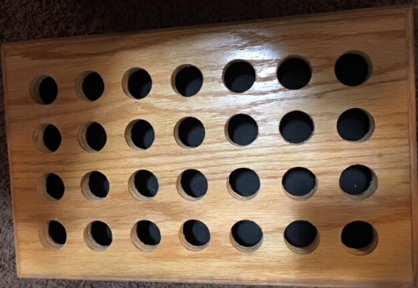

Bath Salts Tube Holder. Holes are 1.5” in diameter. Very sturdy.
10.00
1 each

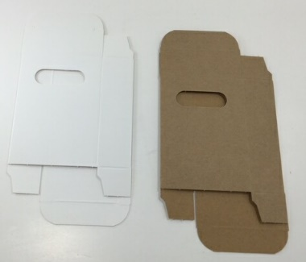

Soap Boxes
2.5” Wide x 3.5” Tall x 1” Wide
Kraft and White
$0.20 Each

Approx 100 each
White Soap Boxe w/Oval Cutout
2 ¾” x 1 ⅜” x 3 ¾”
$0.30 Each
Approx 500

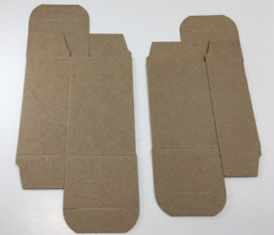

Soap Boxes
2.5” x 4”x 1.75”
0.15 each

2 5/8” x 1.5” x 3.5”
$0.18 each
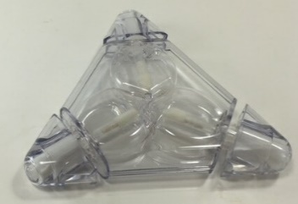
Appropx 500 each

Tri-Color Lip Balm Container
$0.75 Each

48 Available

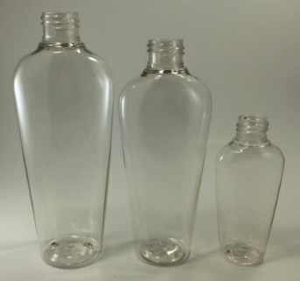
Pet Oval Lotion Bottles
34 - 8 oz - $0.75 Each
50 - 6 oz - $0.50 Each
7 - 4 oz - $0.40 Each (Not shown)
6 - 2 oz - $0.25 Each

I do have some closures for these caps and pumps additional cost.
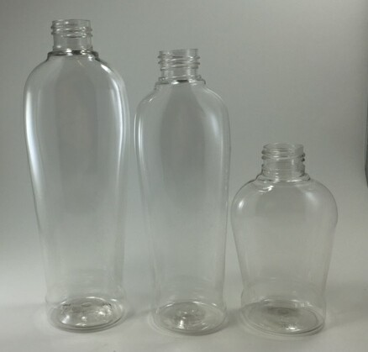

Pet Oval Lotion Bottles Larger Bottom
8 oz includes Pump, Spray, or Flip top Caps. Assorted Spray Top Colors
27- 8 oz – $0.75 Each
7 - 6 oz - $0.50 Each
35 - 4 oz - $0.40 Each

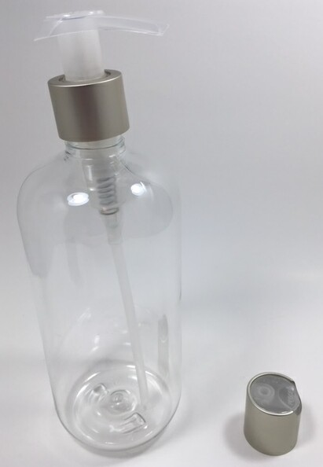

16 oz PET Plastic Boston Round Bottles size 24 closure
$1.00 each. Comes with Pump OR Cap, NOT both.
Approximately 60 left
There is a metal basket that these fit in (see info below in document)

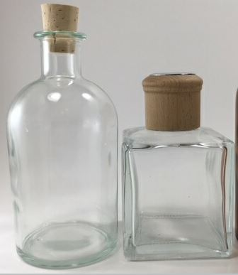

Diffusing Bottles 8 oz
$1.00 Each

12 Round
4 Square
Diffuser rods included

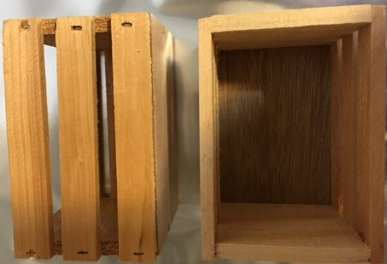

Small wooden crates – good for soaps, bath bombs, or a variety of other things. Dimensions: 3” wide x 4.25” long x 3” deep
$1.00 each 19 each

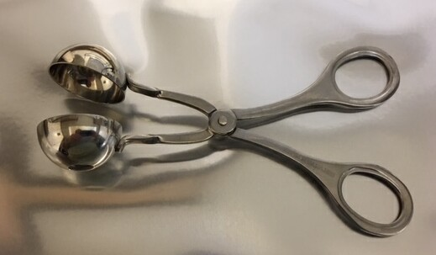

Small Bath Bomb Tongs (Meatball Tongs)
1.25” in diameter
$0.75

1
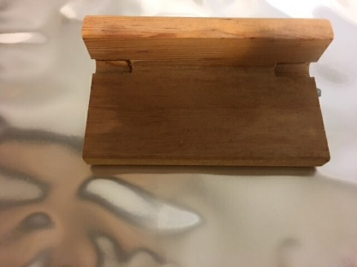

Soap Beveller – Put Single edge razor blade in either side (removed in picture)
$0.50

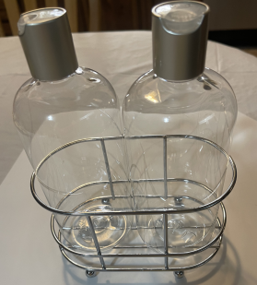

New Metal Base That holds 2 - 16 oz Bottles
8 each
$2.50 each

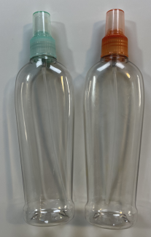
New Spray Head Closures 24 mm size (does not include bottle)
Colors Available:
Misty Mint – 10 (Pictured)
Citrus Tint - 8 (Pictured)
Frosted – 6
Fruit Punch – 19
White – 12
Black – 12
Carnation Pink – 5
Purple Iris – 9
Raspberry – 8
$.50 each

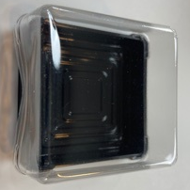
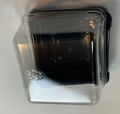
New Small and Medium Bath Bomb Containers for Bath Bomb Packaging
94 each Small (fits 2 oz bomb) $0.25 each
40 each Large ( fits 4 oz bomb) $0.50 each

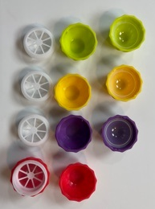

Unused Lip Balm Pots
Hold 0.3 oz
Lime Green
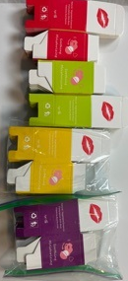
12 each Yellow
12 each Purple
9 each Red
$1.00each

Unused Boxes for above Lip Balm Pots
21 Each Red - $4.75
24 Each Green - $5.00
24 Each Yellow – $5.00
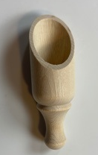
24 Each Purple - $5.00

New 8 each Wooden Scoop
3.5” in length $1.00 each

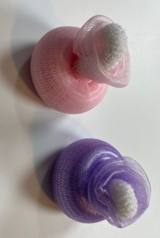

Unused Facial Poufs
31 each Pink
58 each Lavender$ 1.00 each

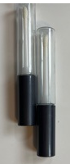

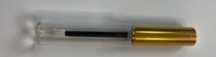
Unused Lip Lube Tubes
73 each Gold Lids $0.50 each
2 each Black Lids $ 0.50 each
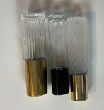

Unused Glass Roller Bottles
6 each Frosted 2/Gold Lid
14 each Plain w/Black Lid
1 each Vertical Striped w/Gold Lid
$1.00 each
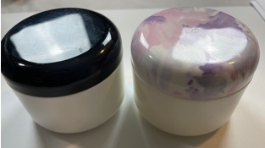

Usused 8 oz Double Wall Jars Size 83-400 Lid
4 each Black Lid
6 each Floral Lid
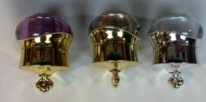
$1.25 Each

New Elegant Plastic Pot Jars
Sliver – 2 each
Gold – 2 each
Purple – 3 each
$1.00 Each

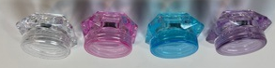
New Colored Plastic Jars
9 each Lavender $0.50 each
10 each Blue $0.50 each
4 each Pink $0.50 each
9 each Clear $0.50 each
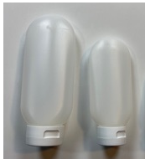

New Tottles w/Lids
14 ea 8 oz HDPE w/White Caps $1.00 each
4 ea 4 oz HDPE w/White Caps $0.75 Each

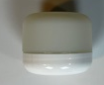
Unused 1 oz Double Wall Jar w/Lid
14 -$0.35 each
43-400 Lid Opening

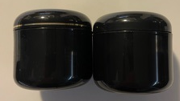
Unused 4 oz Double Wall Jars Black
3 each – 2 w/Gold Band, 1 Plain Black
$0.75 Each
70-400 Size Lid Opening

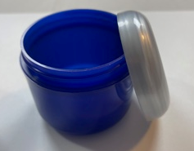
4 oz Double Wall Jars Cobalt Blue 2/Silver Lid
Unused 42 Each
3 have Black Lids
7 Additional Black Lids
$0.75 Each
70-400 Lid Opening

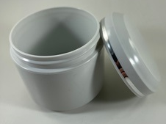
Unused 4 oz Double Wall Jars Grey w/Silver Striped Lid
44 each
2 Additional Lids
$0.75 Each

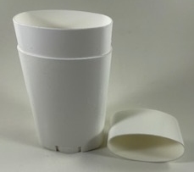
New Large Deodorant Container
31 - 2.5 Oz White PP Plastic Oval Shaped
$0.75 Each

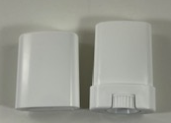
New Small Deodorant Container
10 - $0.50 Each

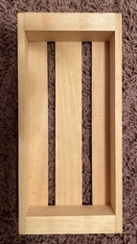

15 each New Long Rectangle Wooden Crate 7.75x3.75.1.25 (inside dimensions)
$3.00 Each

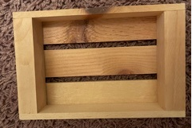
43 each New Short Wood Crate 5”x 3.75” x.125”
$2.00 each

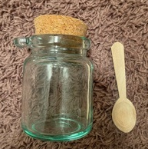
16 each New 8 oz Glass Jar w/Cork Lid & Wooden Spoon
$5.00 Each

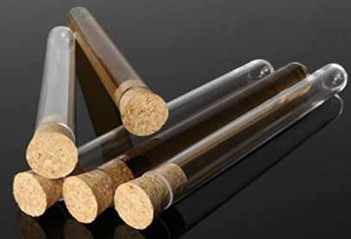
New Polyethylene Tubes w/Cork Lid 6”x0.5”
9 each Packs of 10 $4.00 Each

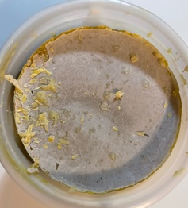
12 each 3 lb Bucket Beeswax
This is a solid block. You will need to either grate it yourself or melt it down and pour it into smaller containers.
$18.00

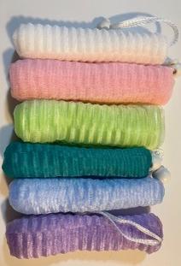

New Nylon Soap Sacks
2 each Pink
4 each Lime Green
42 each Baby Blue
41 each Teal
49 each Lavender
41 each White
$1.25 each

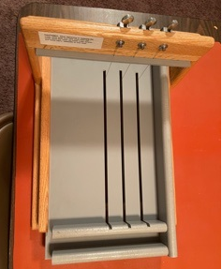

For Craft’s Sake Mini B&B Log Splitter
$246.95 New
$200.00
This has only been used once

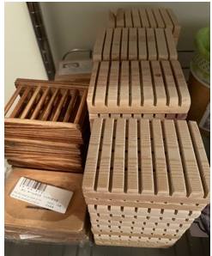

Wooden Soap Decks
$2.00 Each
Approximately 55 Available – Various Sizes & Shapes
5 ea Ladder Type Soap Decks 3.00 each

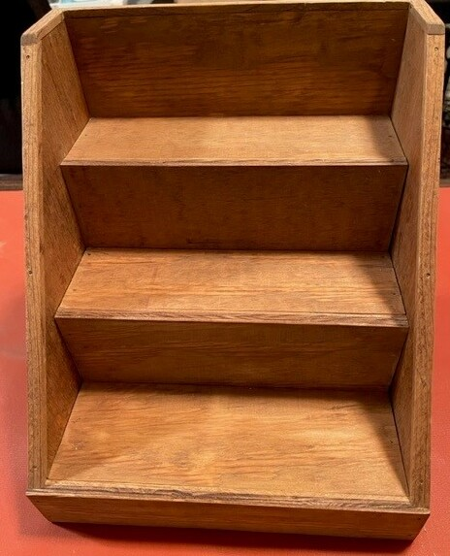

Wooden Display (3 each)
11.25” Tall x 11” Wide by 10.5” Deep
$25.00 Each

